ECSSR Event Management System

Executive Summary
This document provides a unified view of the Enterprise Event Management System, designed for both business stakeholders and technical teams. It explains how events are governed, how work is executed through workflows, and how the system ensures accountability, traceability, and operational excellence.

1. Business View – Event Governance
Events are managed through a controlled lifecycle, ensuring clear ownership, structured execution, and full auditability.
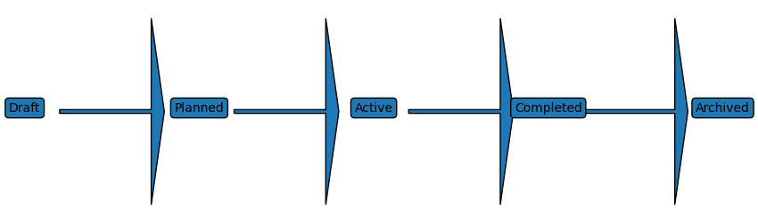

Event Lifecycle Explanation
- Draft: Event is defined
- Planned/Approved: Details finalized and tasks assigned
- Active: Event execution in progress
- Completed: Event concluded
- Archived: Event retained for audit and reporting

2. Operational View – Task Workflow
Each event consists of tasks that are treated as workflow instances. This ensures controlled execution, role-based responsibility, and measurable progress.
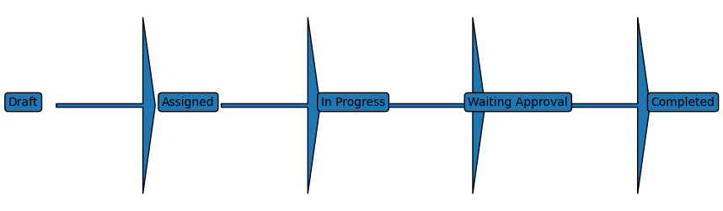

Task Workflow Explanation
- Draft: Task created
- Assigned: Responsibility assigned by Lead
- In Progress: Work underway
- Waiting Approval: Review required
- Completed: Task finalized

3. Roles & Responsibilities (RBAC Summary)
Role | View Event | Manage Tasks | Approve Work | Administer System
Owner | ✔ | ✔ | ✔
Lead | ✔ | ✔ | ✔
Member | ✔ | Assigned Only
Viewer | ✔
System Admin | ✔ | ✔ | ✔ | ✔

5. Notification Flow (Conceptual)
All critical actions generate notifications using a reliable Outbox pattern. Emails are sent asynchronously, ensuring no business action is lost even during system restarts.
Emails are triggered on:

Event Level
- Event created
- Event approved
- Event cancelled
- Event completed

Task Level
- Task assigned
- Task state changed
- Task overdue
- Task completed

Workflow Level
- Transition approval required
- SLA breach warning
User Action → Database Transaction → Outbox Record → Background Worker → Email Delivery

6. Enterprise Value
This architecture aligns with enterprise best practices by ensuring:
- Clear accountability (owners, leads, assignees)
- End-to-end traceability (audit and workflow history)
- High reliability (decoupled notifications)
- Scalability and maintainability

